`` 

Student Name……………………………………

### FURTHER MATHEMATICS

### TRIAL EXAMINATION 2

**2016**

#### Reading Time: 15 minutes

Writing time: 1 hour 30 minutes

###### Instructions to students

This exam consists of Section A and Section B.

Section A contains 9 short-answer and extended answer questions from the core.

Section A is compulsory and is worth 36 marks.

Section B begins on page 12 and consists of 4 modules. You should choose 2 of these modules and answer every question in each of your chosen modules. Each of the modules is worth 12 marks.

Section B is worth 24 marks.

There are a total of 60 marks available for this exam.

The marks allocated to each of the questions are indicated throughout.

Students may bring one bound reference into the exam.

Students may bring into the exam one approved technology (calculator or software) and, if desired, one scientific calculator. Calculator memory does not need to be cleared. For approved computer-based CAS, full functionality may be used.

Unless otherwise stated, the diagrams in this exam are not drawn to scale.

Formula sheets can be found on pages 27 and 28 of this exam.

##### *This paper has been prepared independently of the Victorian Curriculum and Assessment Authority to provide additional exam preparation for students. Although references have been reproduced with permission of the Victorian Curriculum and Assessment Authority, the publication is in no way connected with or endorsed by the Victorian Curriculum and Assessment Authority.*

**© THE HEFFERNAN GROUP 2016**

This Trial Exam is licensed on a non transferable basis to the purchasing school. It may be copied by the school which has purchased it. This license does not permit distribution or copying of this Trial Exam by any other party.

**SECTION A - Core**

**Data analysis**

This section is compulsory.

**Question 1** (5 marks)

The stem plot below shows the number of cars found travelling over the speed limit each day on a suburban road on 30 consecutive days.

key: 0|4 = 4

|  |  |  |  |  |  |  |  |  |
| --- | --- | --- | --- | --- | --- | --- | --- | --- |
| 0 | 4 |  |  |  |  |  |  |  |
| 0 |  |  |  |  |  |  |  |  |
| 1 | 0 |  |  |  |  |  |  |  |
| 1 | 6 |  |  |  |  |  |  |  |
| 2 | 3 |  |  |  |  |  |  |  |
| 2 | 7 | 7 | 9 |  |  |  |  |  |
| 3 | 0 | 2 | 4 |  |  |  |  |  |
| 3 | 5 | 6 | 6 | 7 | 9 | 9 |  |  |
| 4 | 2 | 3 | 3 | 3 | 4 | 4 |  |  |
| 4 | 6 | 6 | 7 | 7 | 8 | 8 | 9 | 9 |

1. For the data shown in the stem plot find
2. the range. 1 mark
3. the mode. 1 mark
4. On what percentage of days were there less than 20 cars found travelling over the speed limit? 1 mark
5. Explain why the day where four cars were found travelling over the speed limit is an outlier for this set of data. Use an appropriate calculation in your explanation. 2 marks

**Question 2** (3 marks)

At a police checkpoint on a freeway, vehicles were randomly selected for a vehicle and licence check.

The two-way frequency table below shows the *licence type* (probationary, full) of the drivers and the *roadworthiness* (roadworthy, unroadworthy) of their vehicles.

|  |  |  |
| --- | --- | --- |
| ***Roadworthiness*** | ***Licence type*** | |
|  | probationary | full |
| roadworthy | 85% | 87% |
| unroadworthy | 15% | 13% |
| total | 100% | 100% |

1. Circle **two** of the following four words that can be used to describe the variable *roadworthiness.* 1 mark

numerical categorical

nominal ordinal

1. Does this data support the opinion that the type of licence a driver has is associated with the roadworthiness of the car they drive?

Justify your answer by using appropriate percentages. 2 marks

**Question 3** (6 marks)

The scatterplot below shows the *number of vehicles* waiting at a level crossing whilst the boom gates were down, against the *time* (in minutes) that the gates were down on 23 occasions.

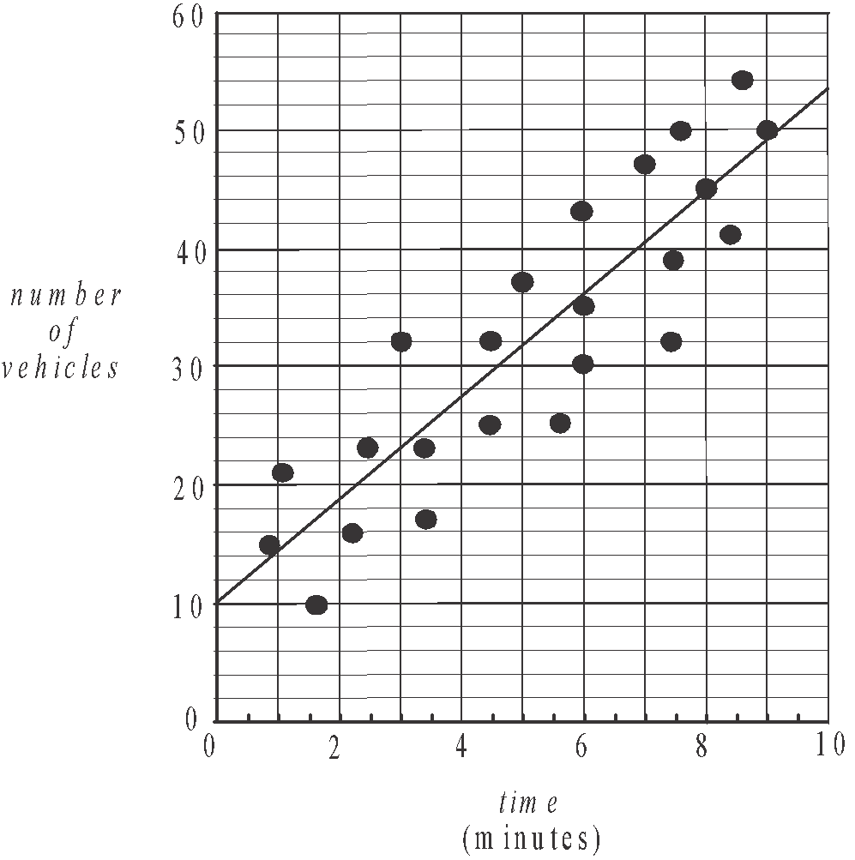

A least squares regression line has been fitted to the scatterplot as shown above.

It has the equation



1. What is the response variable? 1 mark

The slope of the least squares regression line is 4.3.

1. Interpret the slope of the least squares regression line in terms of the variables *number of vehicles* and *time*. 1 mark

The coefficient of determination is 0.78.

1. Interpret the coefficient of determination in terms of the *number of vehicles* waiting and the *time* that the gates were down. 1 mark
2. What is the value of Pearson’s correlation coefficient? Express your answer correct to two significant figures. 1 mark

The residual plot below was drawn in order to test the assumption that the relationship between the variables *number of vehicles* and *time* was linear.

One point is missing from the residual plot.

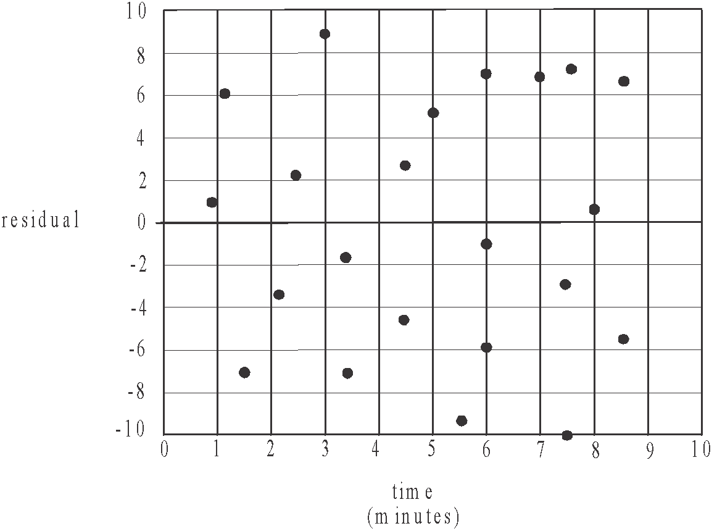

The residual value for the point (9,50) on the scatterplot was not calculated.

1. Find this residual value using the equation of the least squares regression line and plot it on the residual plot above. 1 mark
2. Explain why the residual plot supports the assumption that the relationship between the variables *number of vehicles* and *time* is linear. 1 mark

# Question 4 (3 marks)

The scatterplot and table below show the *number of vehicles* waiting at a different level crossing whilst the boom gates were down, and the *time* (in minutes) that the gates were down on 19 occasions.

|  |  |
| --- | --- |
| time  (minutes) | number of vehicles |
| 1.6 | 4 |
| 2.2 | 6 |
| 3.0 | 8 |
| 4.4 | 6 |
| 5.2 | 8 |
| 6.0 | 8 |
| 6.5 | 15 |
| 7.0 | 10 |
| 7.6 | 20 |
| 7.7 | 40 |
| 8.0 | 14 |
| 8.1 | 34 |
| 8.4 | 20 |
| 8.4 | 31 |
| 8.5 | 44 |
| 8.8 | 50 |
| 9.0 | 14 |
| 9.2 | 36 |
| 9.4 | 56 |

The relationship between the variables *number of vehicles* and *time* is not linear.

In order to linearise the scatterplot, a square transformation is to be applied to the variable *time.*

1. Apply this square transformation to the data above in order to find the equation of the least squares regression line that enables the *number of vehicles* waiting at the level crossing to be predicted from the *time squared*.

Write the intercept and the slope of the line in the boxes below.

Express these values correct to two significant figures. 2 marks





1. Use your answer to part **a**. to predict the number of vehicles waiting at the level crossing when the gates are down for 4 minutes. Round your answer to the nearest whole number. 1 mark

**Question 5** (4 marks)

At a third level crossing, the gates were down on 17 occasions during a particular day.

The *number of vehicles* waiting whilst the gates were down and the *time* (in minutes) that the gates were down was recorded on each occasion.

The table below shows the values of some of the statistics calculated for the data collected at this third crossing.

The variable *time* is taken to be the explanatory variable.

|  |  |  |
| --- | --- | --- |
|  | *time* (*x*) | *number of vehicles* (*y*) |
| mean |  |  |
| standard deviation |  |  |
| correlation coefficient |  | |

1. On one occasion when the boom gates were down, the number of vehicles waiting was 50. Calculate the standard *z*–score of the number of cars waiting on this occasion.

Round your answer to one decimal place. 1 mark

1. Use the information in the table to find the equation of the least squares regression line for the number of vehicles (*y*) in terms of time (*x*). 2 marks

Express the slope and intercept of this line rounded to three significant figures.

Assume that the times that the boom gates are down are approximately normally distributed.

1. On how many of the 17 occasions when the boom gates were down, was the time that they were down expected to be more than one standard above the mean?

Round your answer to the nearest whole number. 1 mark

**Question 6** (3 marks)

The number of commuters passing through a railway station each quarter for the years

2013 – 2015 is given in the table below.

|  |  |  |  |  |  |  |  |  |  |  |  |  |
| --- | --- | --- | --- | --- | --- | --- | --- | --- | --- | --- | --- | --- |
| quarter | Mar ‘13 | Jun ‘13 | Sep ‘13 | Dec ‘13 | Mar ‘14 | Jun ‘14 | Sep ‘14 | Dec ‘14 | Mar ‘15 | Jun ‘15 | Sep  ‘15 | Dec ‘15 |
| number of commuters | 18000 | 22000 | 24000 | 25300 | 27800 | 30400 | 43500 | 47900 | 51300 | 54900 | 56000 | 59000 |

An incomplete time series plot of this data is shown below

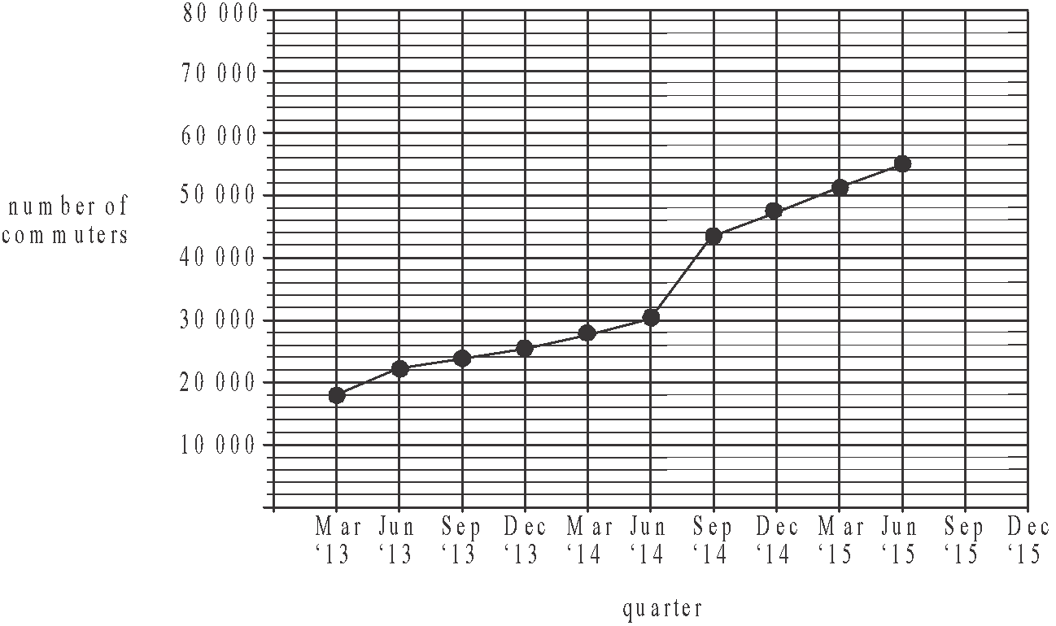

1. On the time series plot above, plot the number of commuters who passed through the station in the September 2015 and December 2015 quarters. 1 mark
2. Describe the features of the time series plot. 1 mark
3. A least squares regression line is fitted to the data for September 2014 to December 2015. It is proposed that this line be used to predict the number of commuters who will use the station in 2020.

Explain why this prediction could be unreliable. 1 mark

**Recursion and financial modelling**

**Question 7** (4 marks)

Jacks’ business owns a car.

The value of this car can be depreciated over time using flat rate depreciation. The value , in dollars, of the car after *n* years can be modelled by the recurrence relation

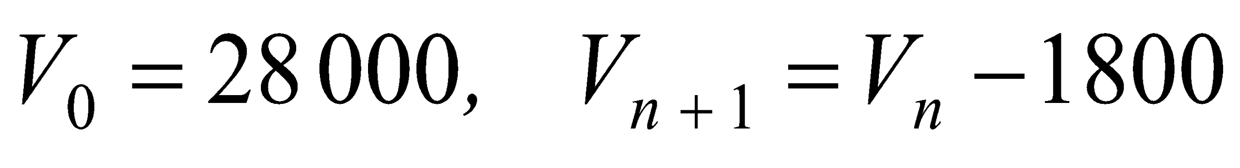

1. Write down the value of the car at the end of the first year and at the end of the second year. 1 mark
2. After how many years will the car have a value of $10 000? 1 mark

The value of the car could also be depreciated using reducing balance depreciation.

Using this method, the value , in dollars, of the car after *n* years would be modelled by the recurrence relation.

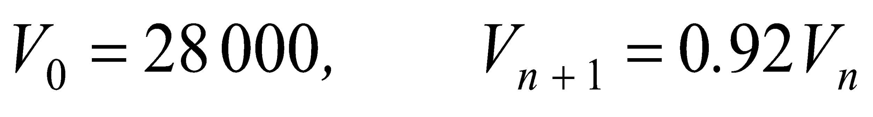

1. After how many years would the car first have a value less than $10 000? 1 mark
2. What is the annual percentage rate by which the car is depreciated using this method? 1 mark

**Question 8** (4 marks)

Jack’s grandfather invested $25 000 in a perpetuity for Jack. Each quarter Jack receives $300 from this perpetuity.

1. What is the annual interest rate that this perpetuity earns? 1 mark

Jack invests $5 000 of his savings into an account earning interest of 3.6% per annum compounding quarterly. At the end of each quarter he adds the $300 from his perpetuity, to this account. Let  be the value of Jack’s investment after *n* quarters.

* 1. **i.** Write down a recurrence relation in terms of  and 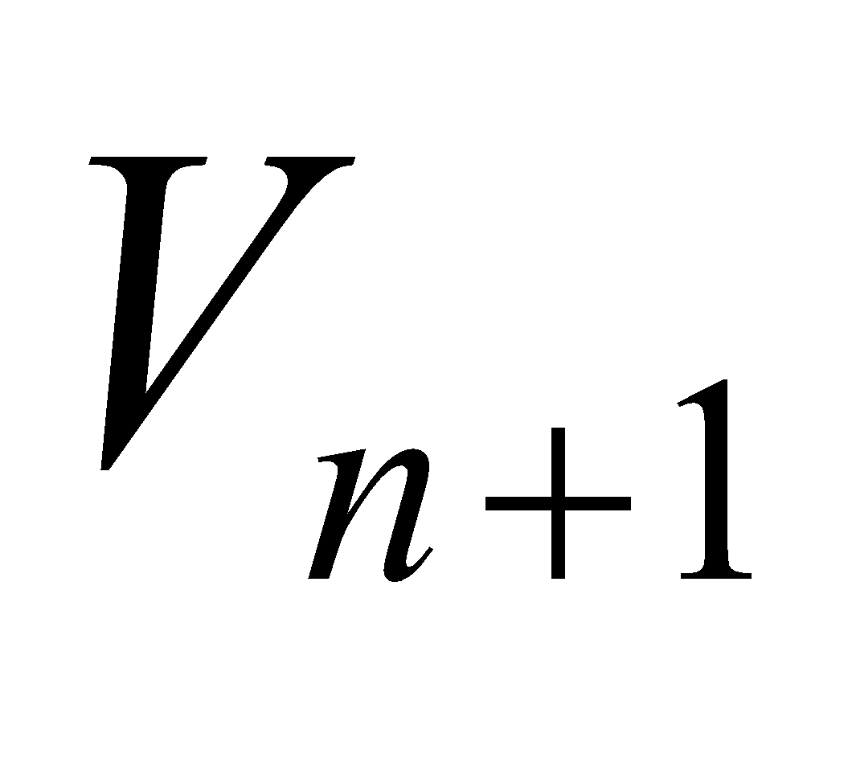that can be used to find the value of Jack’s investment. 1 mark

1. What is the total interest Jack had earned when the value of his investment reached $8 970.47? 2 marks

**Question 9** (4 marks)

Jack borrows $230 000 to expand his business. He makes monthly repayments of $3 800 on this loan. Interest is calculated and paid monthly at the rate of 5.4% per annum.

1. How many repayments must be made to repay this loan fully? Round your answer to the nearest whole number. 1 mark
2. Find the amount that is paid off the principal of the loan after two years. 1 mark

Two years into the loan, the interest rate was increased to 6% per annum. Jack decided to fully repay the loan with just ten further monthly repayments.

1. What was the amount of the next repayment made by Jack? 1 mark
2. What is the amount of Jack’s final repayment which sees the loan fully repaid? 1 mark

**SECTION B - Modules**

**Module 1: Matrices**

If you choose this module all questions must be answered.

**Question 1** (5 marks)

Liam (*L*), Maddie (*M*), Nora (*N*), Oshi (*O*) and Paul (*P*) all meet for the first time on a cruise ship. Some of them exchange contact details at the end of the cruise.

The communication matrix *C* for this group of five people is shown below where a ‘1’ indicates that two people have a one-step communication link, that is, they are in direct contact. A ‘0’ indicates that two people are not in direct contact.

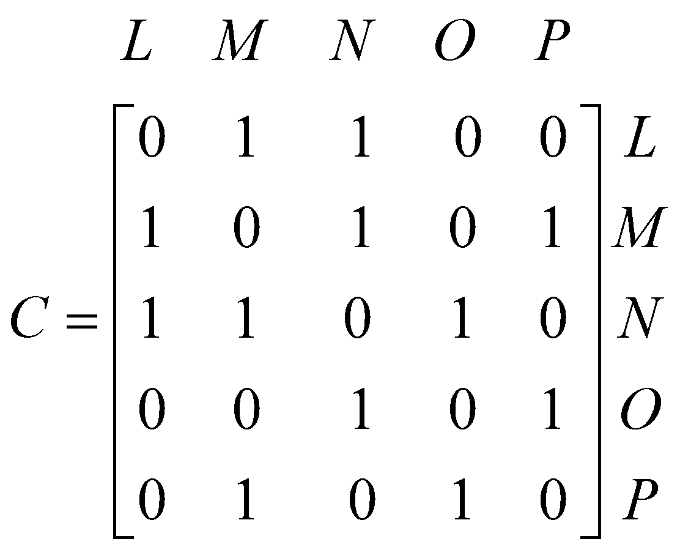

1. Find the sum of the elements of the second column of matrix *C*. 1 mark
2. With respect to the five people in the group, what does the sum of the elements in the second column of matrix *C* represent? 1 mark

The matrix *D* below shows the two-step communication links that exist in the group.

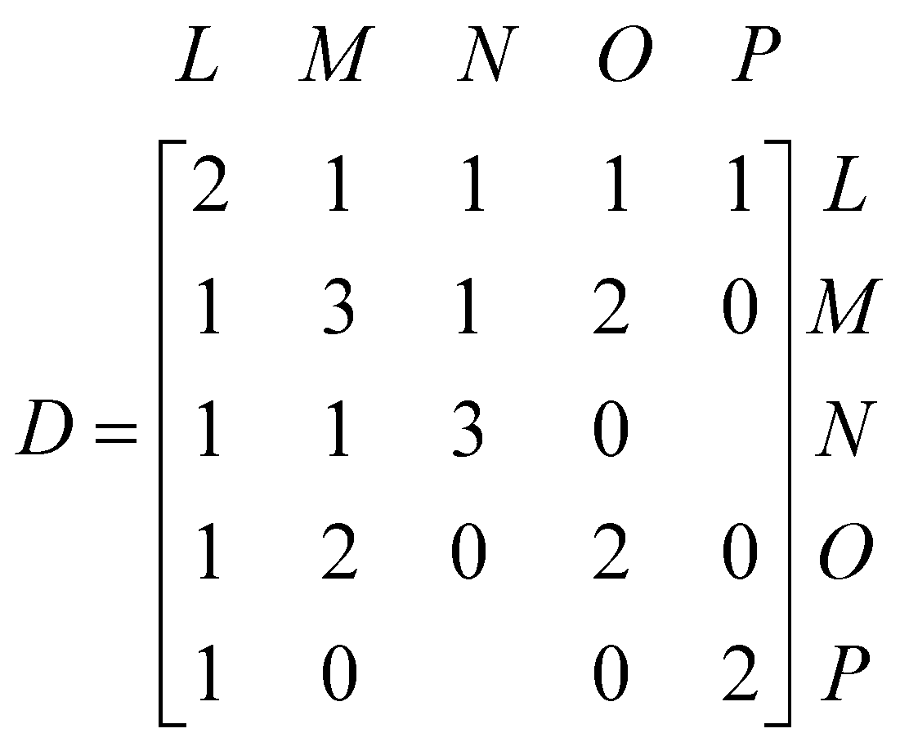

Two elements of this matrix are missing.

1. Complete matrix *D* by writing the missing elements in the shaded boxes. 1 mark
2. Explain why we should ignore the entries in the leading diagonal of matrix *D*. 1 mark
3. Using the sum of the one and two-step communication links for the group, find the two people who have the most links to other members of the group. 1 mark

**Question 2** (7 marks)

A new cruise ship has 320 hospitality staff on board. There are 140 kitchen staff (*K*), 50 bar staff (*B*), and 130 cleaning staff (*C*) on the ship prior to its first cruise.

After each cruise, these staff can remain in their current role or change to a different role or leave the ship (*L*).

The transition matrix *T,* below, shows the way management expects staff will change their role after each cruise.

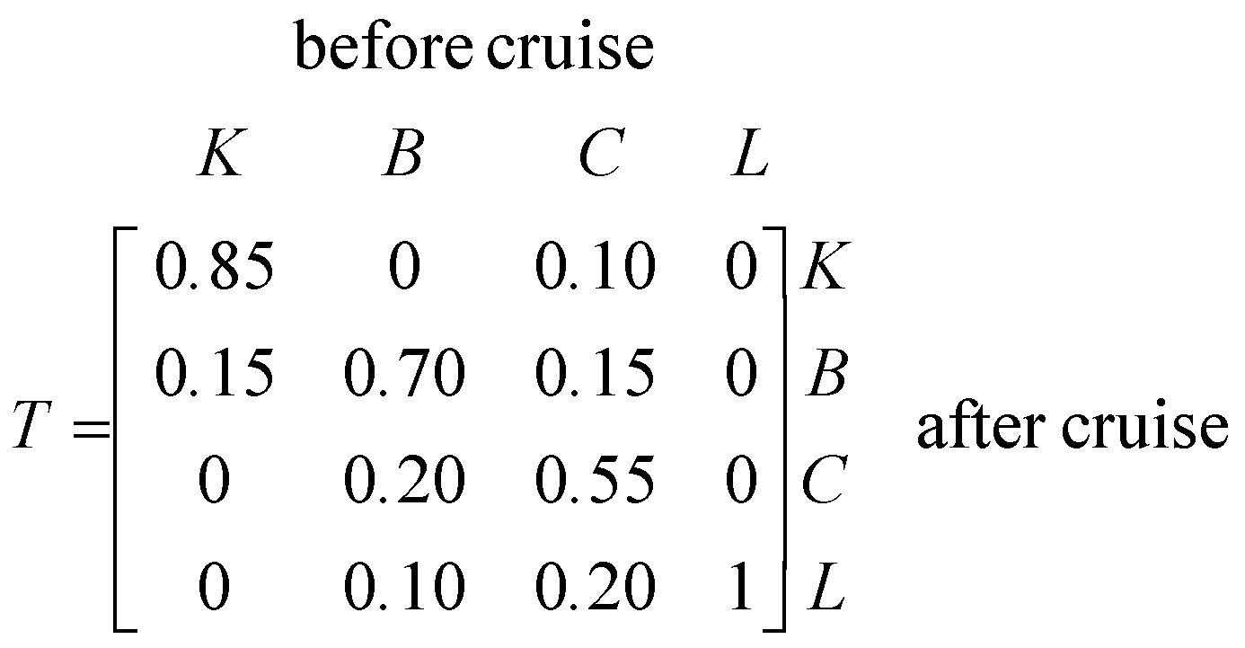

1. How many cleaning staff are expected to leave the ship after the first cruise? 1 mark
2. How many new hospitality staff does management expect to have to employ after the first cruise in order to keep the total number of hospitality staff constant? 1 mark
3. A transition diagram for matrix *T* is shown below. This diagram is incomplete. Complete the transition diagram by inserting any missing information. 1 mark

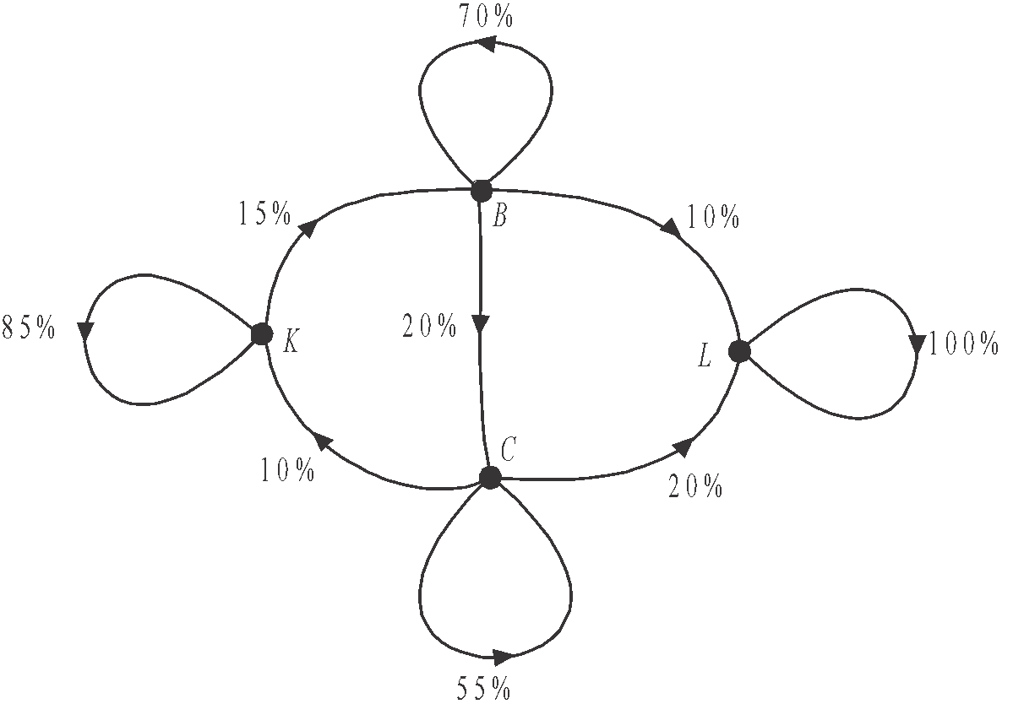

The number of staff on the ship in each of the categories prior to the first cruise is given by the matrix.

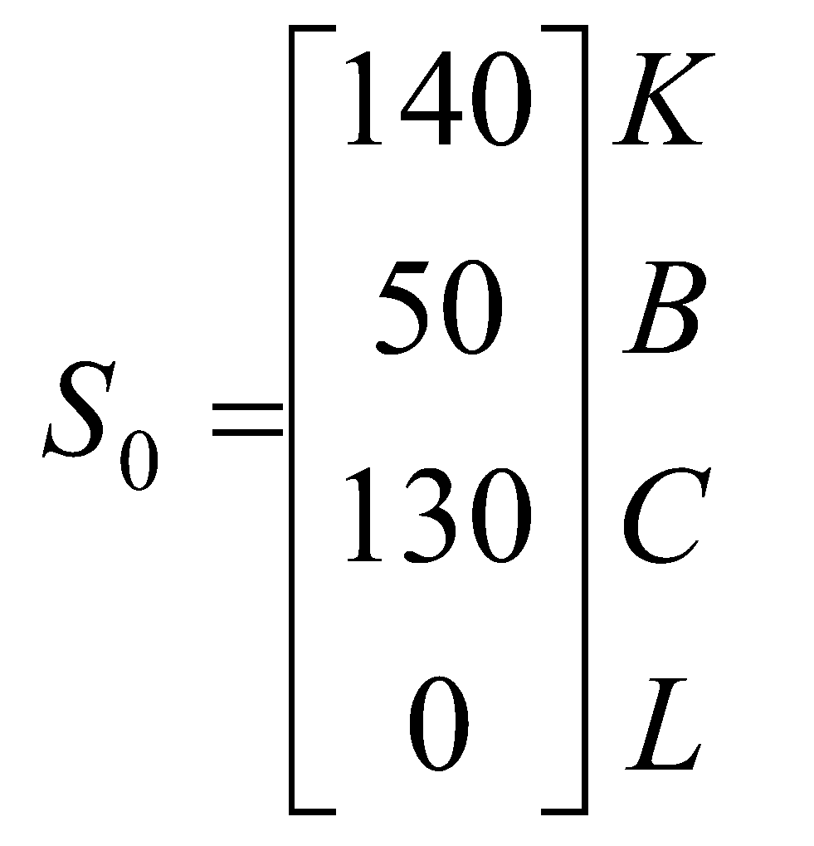

If the staff continues to change their roles on the ship as expected, the matrix  will give management the number of kitchen (*K*), bar (*B*) and cleaning *(C*) staff on board after the *n*th cruise as well as the number of staff who leave (*L*) the ship.

Management uses the rule 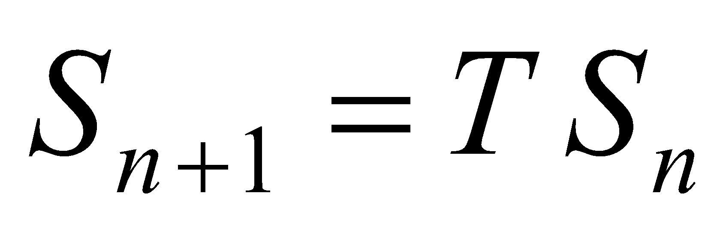 to calculate their staff numbers.

1. Find the number of cleaning staff expected to be on the ship after the second cruise. Write your answer correct to the nearest whole number. 1 mark
2. After which cruise is it expected that the number of hospitality staff will first drop below half the original number? 1 mark

In order to boost the number of hospitality staff on the ship, management considers adding 20 new kitchen staff, 10 new bar staff and 15 new cleaning staff after each cruise.

This means that matrix 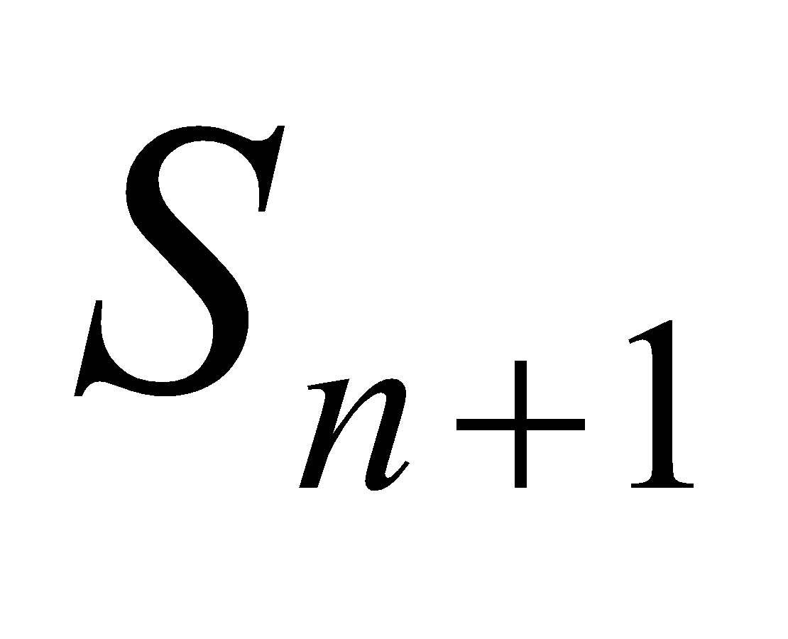 would be given by

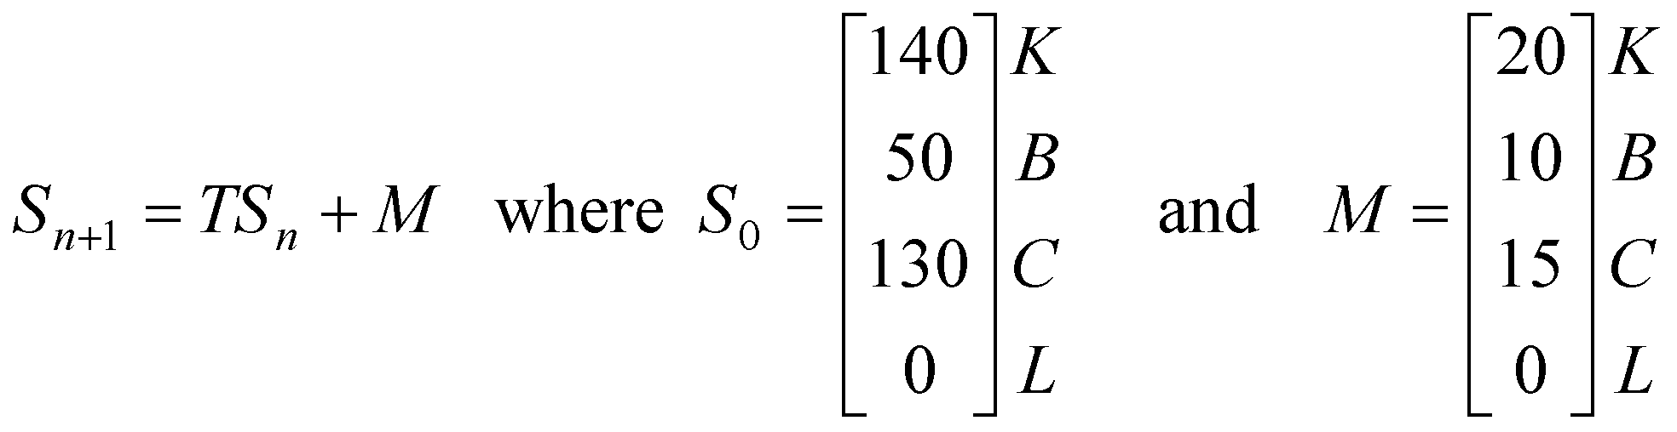

1. Find the number of cleaning staff expected to be on the ship after the second cruise if this boost in staff numbers takes place. Write your answer to the nearest whole number. 2 marks

**Module 2: Networks and decision mathematics**

If you choose this module all questions must be answered.

**Question 1** (4 marks)

A building supervisor oversees construction at seven different building sites.

These sites are indicated by the vertices *A, B, C, D, E, F* and *G* on the graph below.

The edges of the graph indicate roads that connect the various sites.

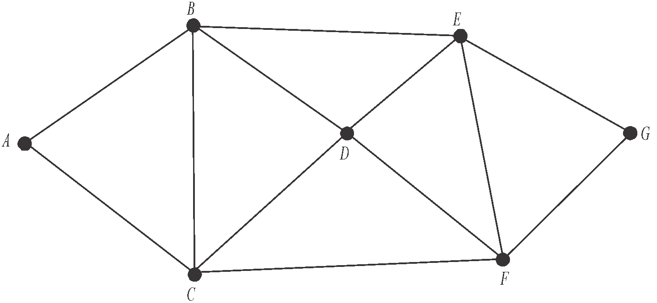

1. What is the sum of the degrees of the vertices of this graph? 1 mark
2. The supervisor can start at any of the sites, and complete an Eulerian circuit. Explain why this is the case. 1 mark
3. On Monday, the supervisor travelled the route *ACFGEBA*. What is the mathematical name given to this route. 1 mark
4. On Tuesday the supervisor started at site *A* and completed a Hamiltonian path finishing at *B*. Write down the sites, in order, that the supervisor could have taken. 1 mark

# Question 2 (2 marks)

The distances, in kilometres, between the various sites are shown on the graph below.

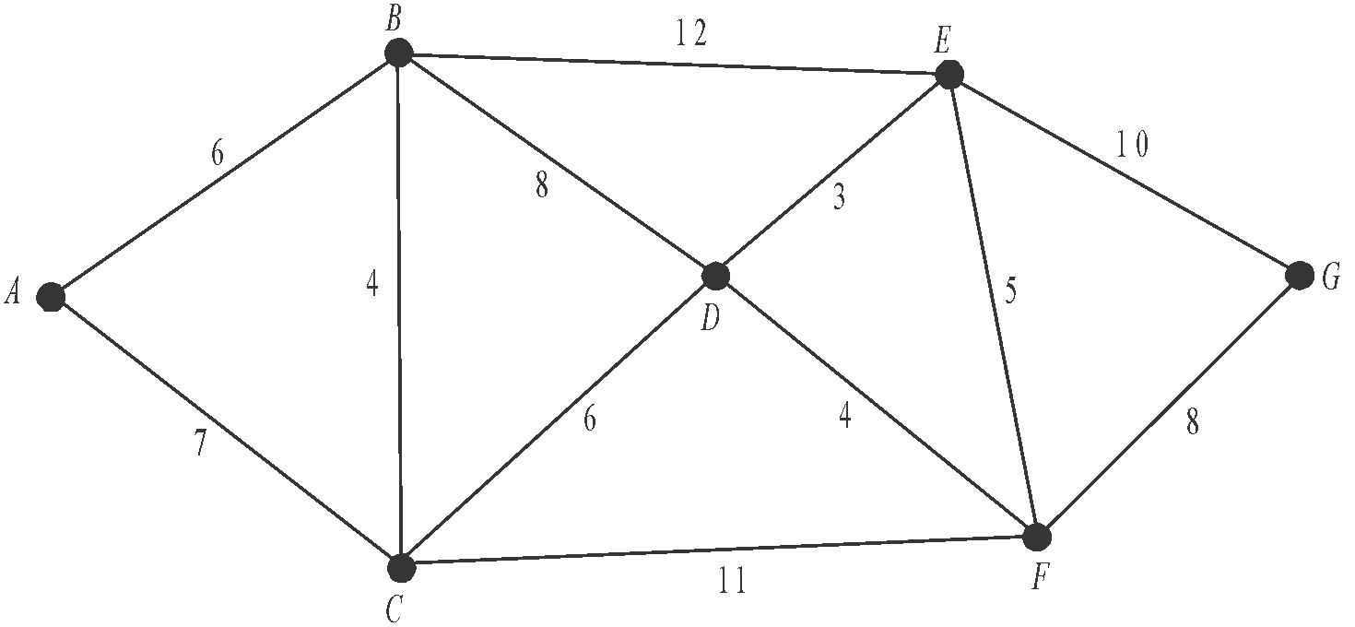

The supervisor has to travel from site *A* to site *G*.

Use Djikstra’s algorithm to find

1. The shortest distance, in kilometres, that he can travel. 1 mark

**ii.** The sites, in order, that he passes through to achieve the shortest distance. 1 mark

**Question 3** (6 marks)

At one of the building sites there are eleven activities that are awaiting completion.

The directed network below shows these eleven activities *A*–*K* together with the completion time, in days, for ten of them.

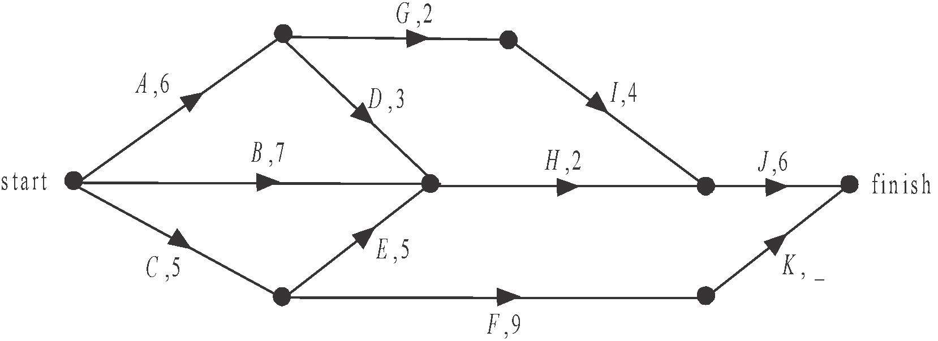

The completion time for activity *K* is missing.

It is known that the minimum completion time for the project at this site is 19 days.

1. What is the earliest starting time for activity *H*? 1 mark
2. What is the duration of activity *K*? 1 mark
3. What is the latest start time for activity *A*? 1 mark
4. Which activities lie on the critical path? 1 mark

The building supervisor insists that activity *F* must be completed before activity *J* can begin.

1. **i.** On the directed network below, show this change, ensuring that no activities are repeated. 1 mark

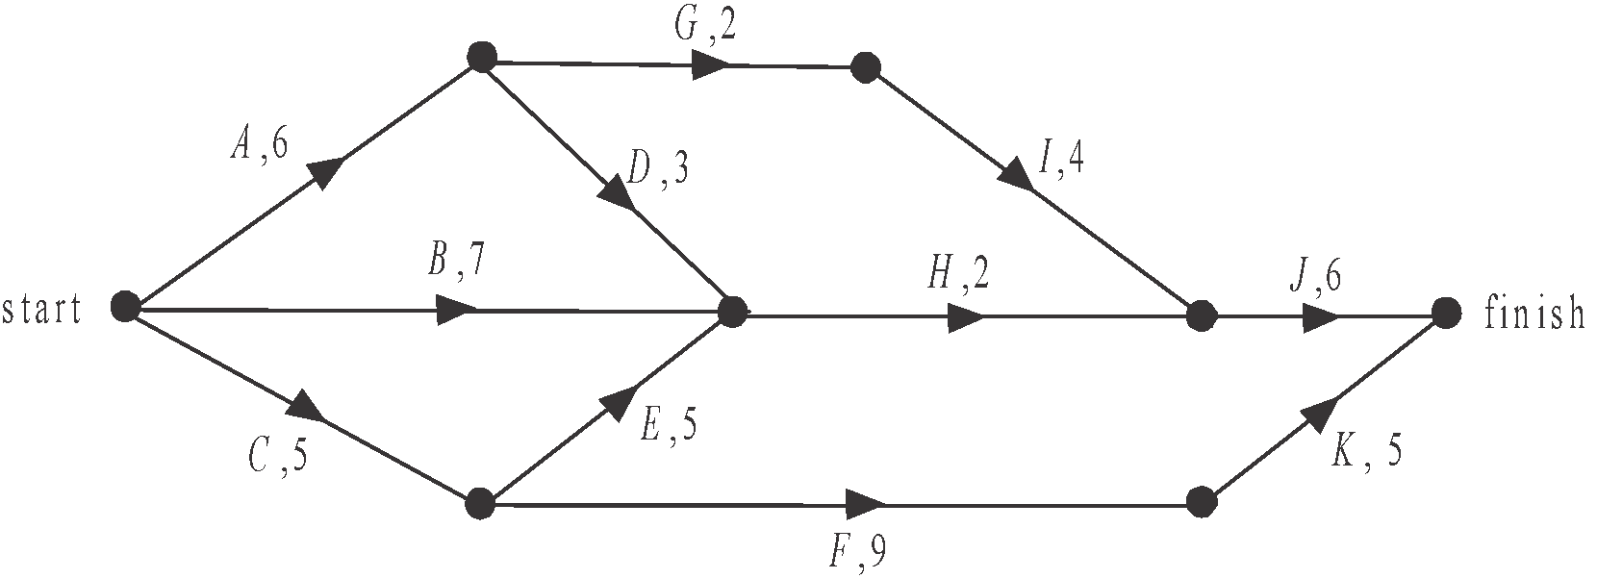

1. What effect will this have on the minimum completion time for the project? 1 mark

# Module 3: Geometry and measurement

If you choose this module all questions must be answered.

# Question 1 (2 marks)

A cylinder of length 6 m and radius 2 m fits exactly inside a shipping container as shown below.

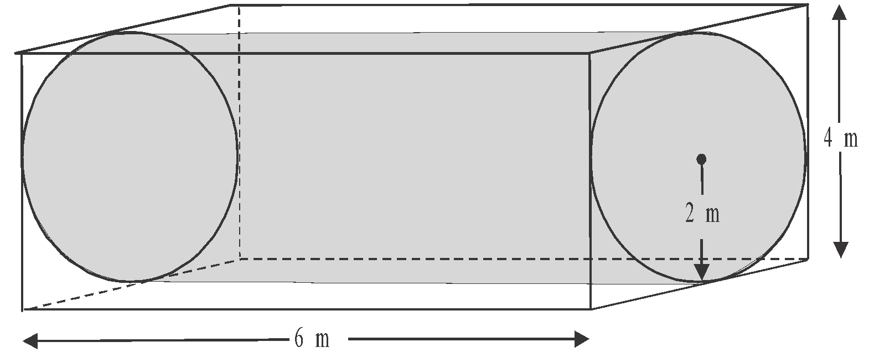

The shipping container is in the shape of a square prism with length 6 m and sidelengths of

4 m.

1. What is the surface area of the cylinder.

Round your answer to the nearest square metre. 1 mark

1. Find the volume of empty space surrounding the cylinder inside the shipping container.

Round your answer to the nearest cubic metre. 1 mark

# Question 2 (2 marks)

A metal pole inside the cylinder runs from the midpoint of a bottom edge of the shipping container at point *A* to point *B*. Point *B* is located at the midpoint of a top edge of the shipping container as shown below.

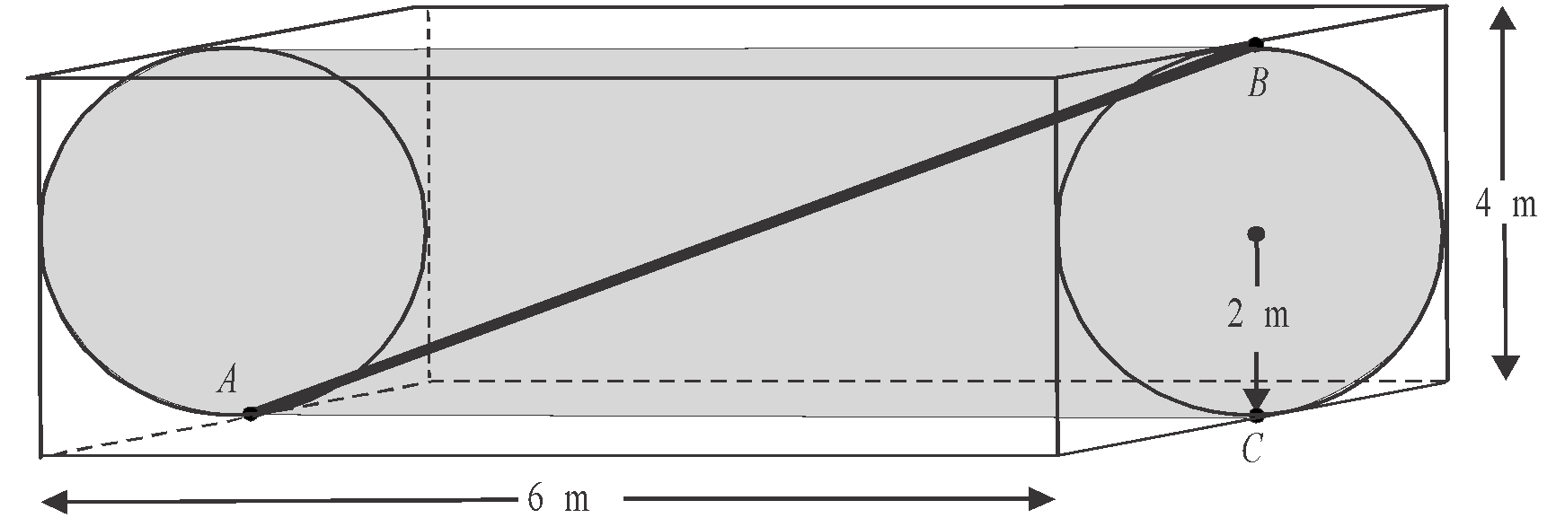

Point *C* lies vertically below point *B*.

1. Find the length of the pole.

Express your answer in metres correct to two significant figures. 1 mark

1. Find angle *ABC*.

Round your answer to the nearest degree. 1 mark

# Question 3 (5 marks)

A ship located at point *S* is to sail 67 km on a bearing of 055° to reach point *T*. From there, it will turn and sail 52 km due east to reach the port at point *P* as shown below.

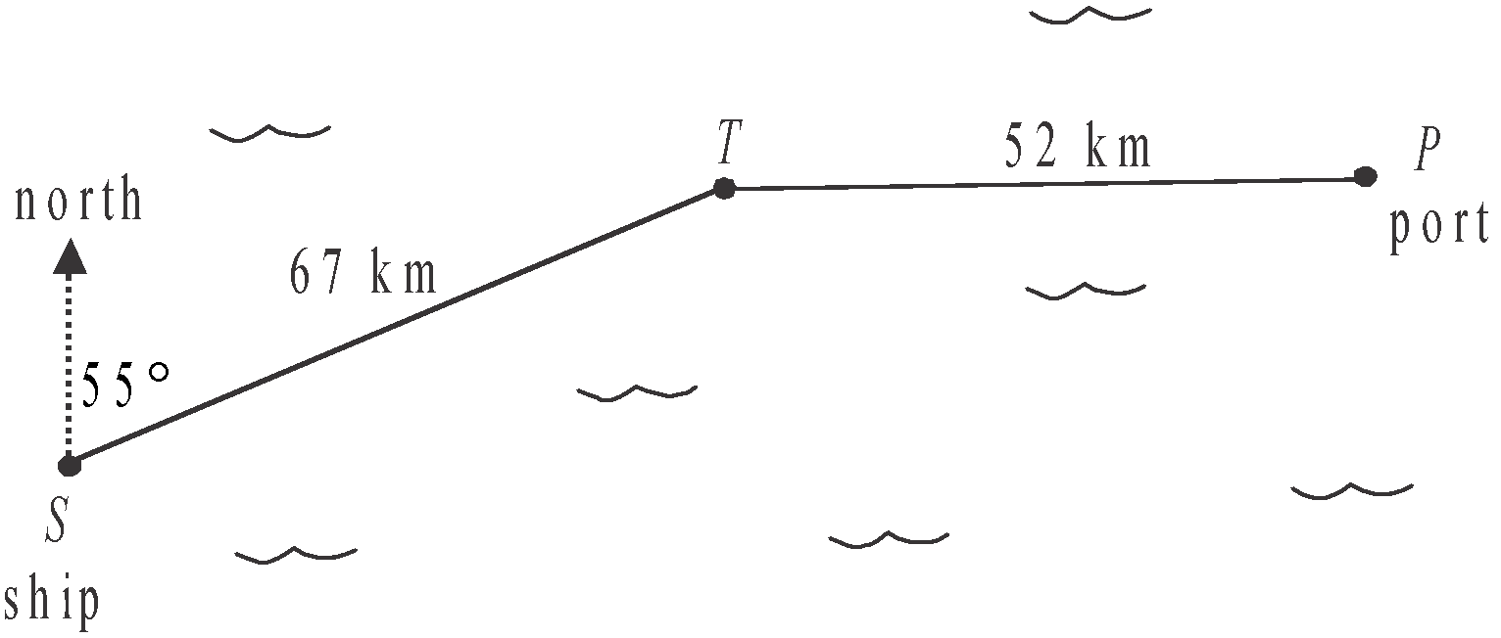

1. How far north of the ship is the port?

Round your answer to the nearest kilometre. 1 mark

1. Show that angle *PTS* is 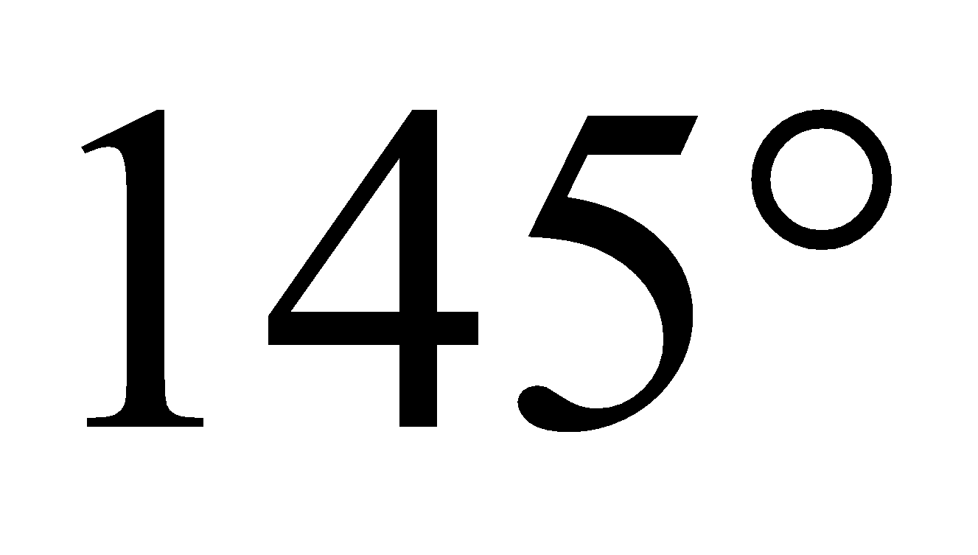. 1 mark
2. Find the straight line distance from the ship to the port.

Round your answer to the nearest kilometre. 1 mark

1. Use the sine rule to find the bearing of the ship from the port.

Round your answer to the nearest degree. 2 marks

**Question 4**  (3 marks)

In the diagram below, the sphere models earth and has a radius of 6400 km and a centre at *C*.

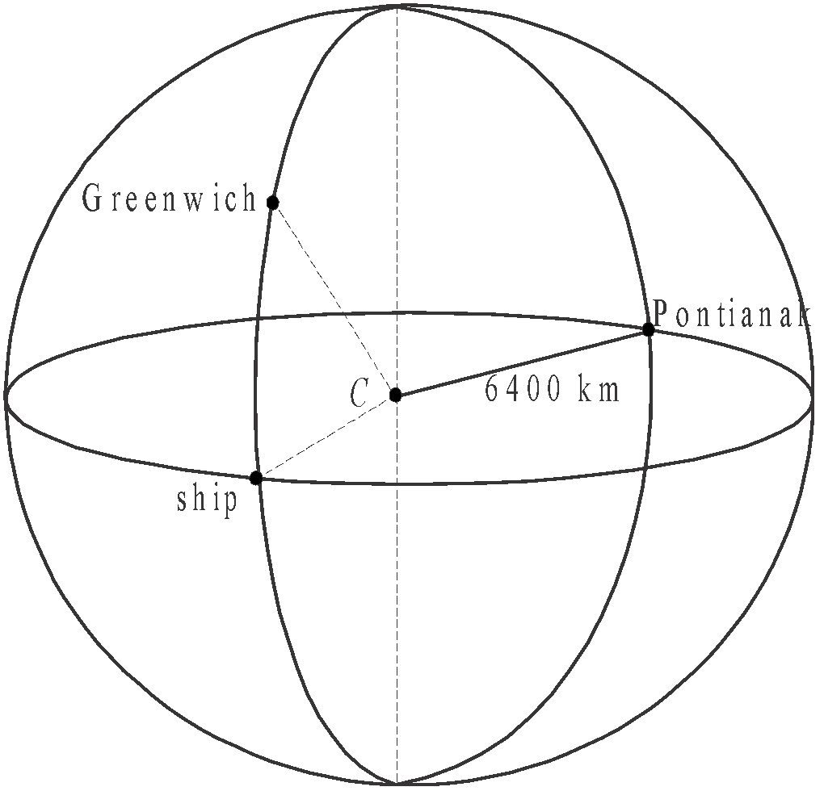

Greenwich has a latitude of 52°N and a longitude of 0°, the ship has a latitude of 0° and a longitude of 0° and the town of Pontianak (in Indonesia) has a latitude of 0° and a longitude of 110°E.

1. What is the time difference between Greenwich and Pontianak? 1 mark
2. Find the great circle distance between Greenwich and the ship, correct to the nearest kilometre. 1 mark
3. Find the great circle distance between the ship and Pontianak, correct to the nearest kilometre. 1 mark

**Module 4: Graphs and relations**

If you choose this module all questions must be answered.

**Question 1** (6 marks)

Customers who want additional monthly data on their phone plan can sign up for an additional data package.

The cost of such a package is determined by the amount of additional monthly data that is used.

The graph below shows the *cost*, in dollars, of using additional monthly *data*, in gigabytes, in a package offered by the Talkeasy phone company.

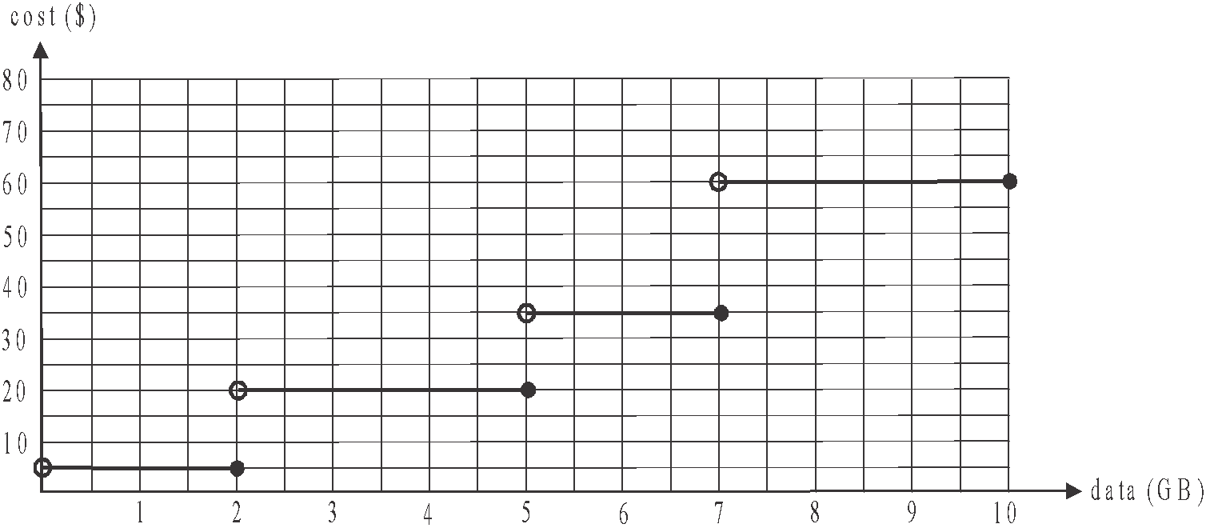

1. What is the maximum amount of additional monthly data that a customer can obtain for $20 on a Talkeasy package. 1 mark

The *cost* of purchasing additional monthly *data* in a package offered by rival phone company Bellstra, is given by



where the *cost* is in dollars and the *data* is measured in gigabytes. The amount of additional monthly *data* available is capped at 10 GB.

1. On the **graph above**, sketch this line. Indicate clearly the endpoints. 1 mark

**c.** Interpret the intercept on the vertical axis of the graph drawn in part **b.** in terms of the

cost of purchasing additional monthly data with Bellstra’s package. 1 mark

1. What is the cost of purchasing each additional gigabyte of data if you are on the Bellstra package? 1 mark
2. A customer needs to purchase an additional 7 gigabytes of data one month. Use figures to explain whether Talkeasy or Bellstra offer the better package for this customer. 1 mark
3. Tony has a package with Talkeasy and Barry has a package with Bellstra. Last month they both used the same amount of additional data and paid the same amount for the additional data they had used. How much additional data did Tony and Barry each use last month? Round your answer to one decimal place. 1 mark

# Question 2 (6 marks)

Stella runs a small business.

Let *x* be the number of smart phones available for use in the business.

Let *y* be the number of laptops available for use in the business.

Because of the phone plan and the leasing plan that the business has in place, there can be up to 10 smart phones and up to 8 laptops available for use in the business.

Each smart phone in the business uses an average of 3 gigabytes of data a month and each laptop uses an average of 5 gigabytes a month. The business has up to 30 gigabytes of data available for smart phone and laptop use each month.

Inequalities 1–3 below represent this information.

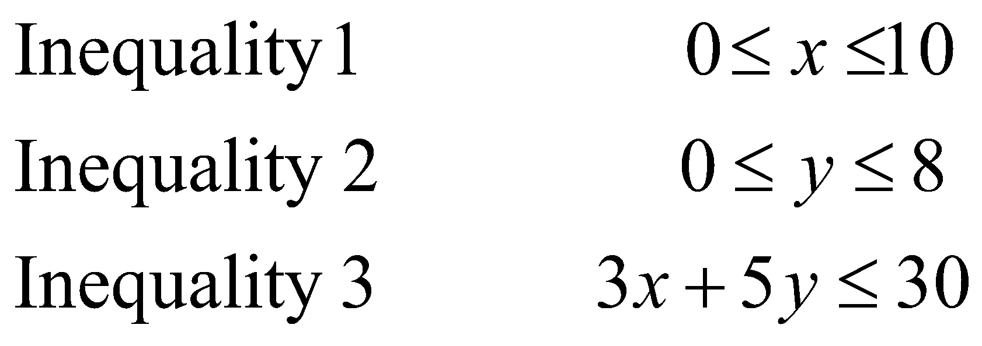

A fourth constraint is given by .

1. Explain the meaning of this fourth constraint in terms of the number of smart phones and laptops that are available for use in the business. 1 mark

The graph below shows the straight lines which represent the boundaries of the four inequalities.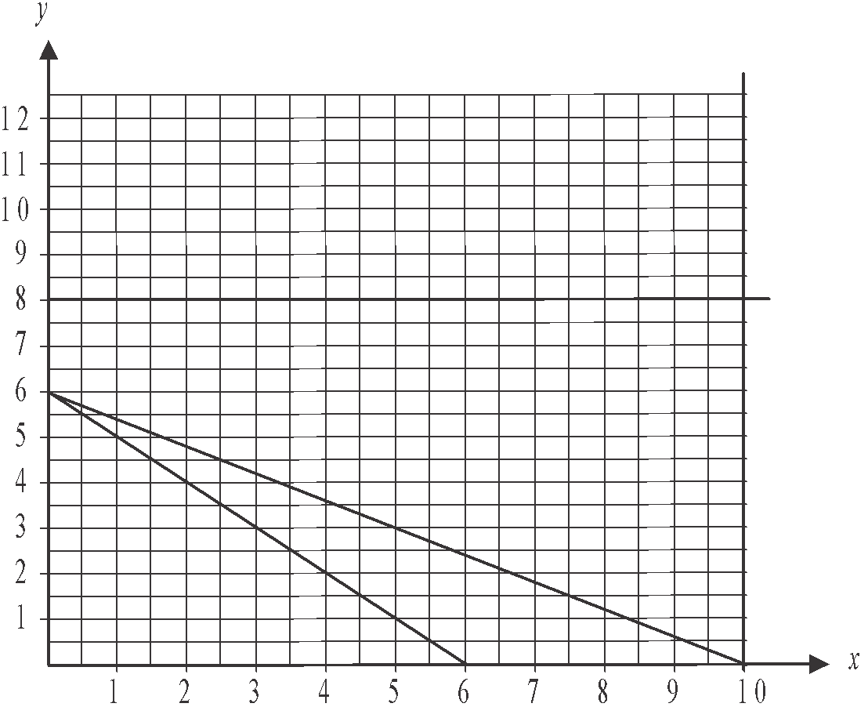

1. On the graph above, shade the region that satisfies inequalities 1–4. 1 mark
2. If the business has four smart phones available for use, what is the maximum number of laptops it can have available for use? 1 mark

An analysis undertaken by the business suggests that on average, each smart phone available for use in the business is used to reach 30 new clients a month.

Each laptop is used on average to reach 50 new clients a month.

1. Write an objective function for *N*, the total number of new clients reached by use of a smart phone and by use of a laptop in a month. 1 mark
2. What is the maximum number of new clients that the business can reach each month by use of smart phones and/or laptops. 1 mark

Stella tells her office manager that there must be at least one smart phone and at least one laptop available for use in the business.

1. Find the number of smart phones and the number of laptops that the business should now have available for use in order to maximize the number of new clients reached each month. 1 mark

Further Mathematics formulas

Core - Data analysis

|  |  |
| --- | --- |
| standardised score |  |
| lower and upper fence in a boxplot |  |
| least squares line of best fit |  |
| residual value | residual value = actual value – predicted value |
| seasonal index | seasonal index |

Core – Recursion and financial modelling

|  |  |
| --- | --- |
| first-order linear recurrence relation |  |
| effective rate of interest for a  compound interest loan or investment |  |

### Module 1 - Matrices

|  |  |
| --- | --- |
| determinant of a  matrix |  |
| inverse of a  matrix |  |
| recurrence relation | , |

Module 2 - Networks and decision mathematics

|  |  |
| --- | --- |
| Euler’s formula |  |

Module 3 – Geometry and measurement

|  |  |
| --- | --- |
| area of a triangle |  |
| Heron's formula |  |
| sine rule |  |
| cosine rule |  |
| circumference of a circle |  |
| length of an arc |  |
| area of a circle |  |
| area of a sector |  |
| volume of a sphere |  |
| surface area of a sphere |  |
| volume of a cone |  |
| volume of a prism |  |
| volume of a pyramid |  |

**Module 4 – Graphs and relations**

|  |  |
| --- | --- |
| gradient (slope) of a straight line |  |
| equation of a straight line |  |

#### END OF FORMULA SHEET

***Mathematics Formula Sheets reproduced by permission; © VCAA 2016. The VCAA does not endorse or make any warranties regarding this study resource. Current and past VCAA VCE® exams and related content can be accessed directly at*** [***www.vcaa.vic.edu.au***](http://www.vcaa.vic.edu.au)